CSIT314 Software Development Methodologies - Group Project

Sprint 1 - US7: Search user profiles
Interior Design Platform - User Admin
All diagrams were drawn in draw.io. Open "US7 Search user profiles.drawio" in this folder to edit them - each diagram is its own page in that file. The exported images are in the "diagrams" folder.

Assumptions
- The system is the Interior Design Platform from the project specification. Sprint 1 covers the User Admin's stories: log in and log out (US1, US2), managing user profiles (US3 - US7) and managing user accounts (US8 - US12).
- A user profile is a user group, e.g. User Admin, Interior Designer, Customer or Platform Manager. It has a name, a description, a list of permissions (what its users can do) and a status (Active or Suspended). Every user account belongs to exactly one user profile.
- We follow B-C-E: the actor only talks to the boundary (page), the boundary only talks to the controller, and the controller works with the entity classes. There is one controller per use case.
- Who checks what: the boundary (page) trims the keyword (just spaces counts as empty). The controller just calls the entity and returns the result. The entity searches the database (capitals ignored) and returns the matching profiles - it doesn't trim or change anything.
- Being logged in as a User Admin (UC1) is a precondition, not a step: loginRequired in app.py only sends someone with no session to /login, and this use case doesn't check the role again.
- US8 Create user account and US10 Update user account borrow this use case's SearchUserProfileController (search with an empty keyword) for their profile drop-down.
- The search checks the profile's name and description for the keyword. Capital letters don't matter, and the page trims the spaces around the keyword.
- If the keyword is empty, all the profiles are shown. This is also how the User Profiles page lists every profile.
- Suspended profiles still show up in the results (with their status next to them), because the admin might still need to find them.
- Searching doesn't change any data.

1. User story
Story ID | US7
User story | As a user admin, I want to search for user profiles so that I can find the group I need to manage.
Actor | User Admin
Priority | Medium
Story points (estimate) | 2
Acceptance criteria | 1. Given I am on the User Profiles page, there is a search box and a "Search" button.  2. Given I type part of a profile name or description and click "Search", then I see every profile that matches, with its description and status.  3. Capital letters don't matter (e.g. "dESIGNER" finds "Interior Designer"), and spaces around the keyword are ignored.  4. Given the keyword is empty, then all profiles are shown.  5. Given nothing matches, then I see "No user profiles found".  6. Suspended profiles are included in the results.
Tasks | #85 Draw Search User Profiles Use Case Diagram  #86 Write Search User Profiles Use Case Description  #87 Draw Search User Profiles BCE Diagram  #88 Draw Search User Profiles Sequence Diagram  #89 Design Search User Profiles Wireframe  #90 Write and Execute Search User Profiles Test Cases

2. Use case diagram
The user story becomes one use case, UC7 Search user profiles. The User Admin is the only actor.
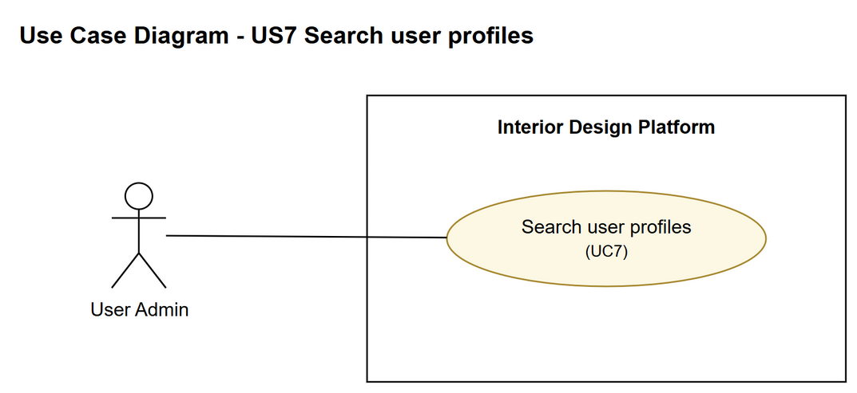
Figure 1: Use case diagram for US7 Search user profiles

3. Use case description
Use case | UC7 Search user profiles
Actor | User Admin
Brief description | The User Admin searches the user profiles by keyword to find the group they need to manage.
User story | US7: As a user admin, I want to search for user profiles so that I can find the group I need to manage.
Preconditions | The User Admin is logged in (UC1).
Trigger | The User Admin types a keyword into the search box on the User Profiles page and clicks "Search".
Basic flow | 1. The User Admin types a keyword (e.g. part of the group's name) and clicks "Search".  2. The system trims the keyword and looks through all the user profiles for ones that have the keyword in their name or description.  3. The system shows a list of the matching profiles, with each one's name, description, status and a "View" link.  4. The User Admin picks the profile they want to manage. From here they can view, update or suspend it, but those are separate use cases.
Alternative flows | 1a. If the keyword is left empty, the system just shows all the user profiles.  3a. If nothing matches, the system shows "No user profiles found" and the User Admin can try a different keyword (back to step 1).
Postconditions | Nothing in the system is changed. The User Admin has found the profile they were looking for.

4. Wireframes
The wireframes were drawn in draw.io. They are low-fidelity: they show the layout and the flow, not the final colours. The orange numbers match the notes under each screen.

4a - Search results
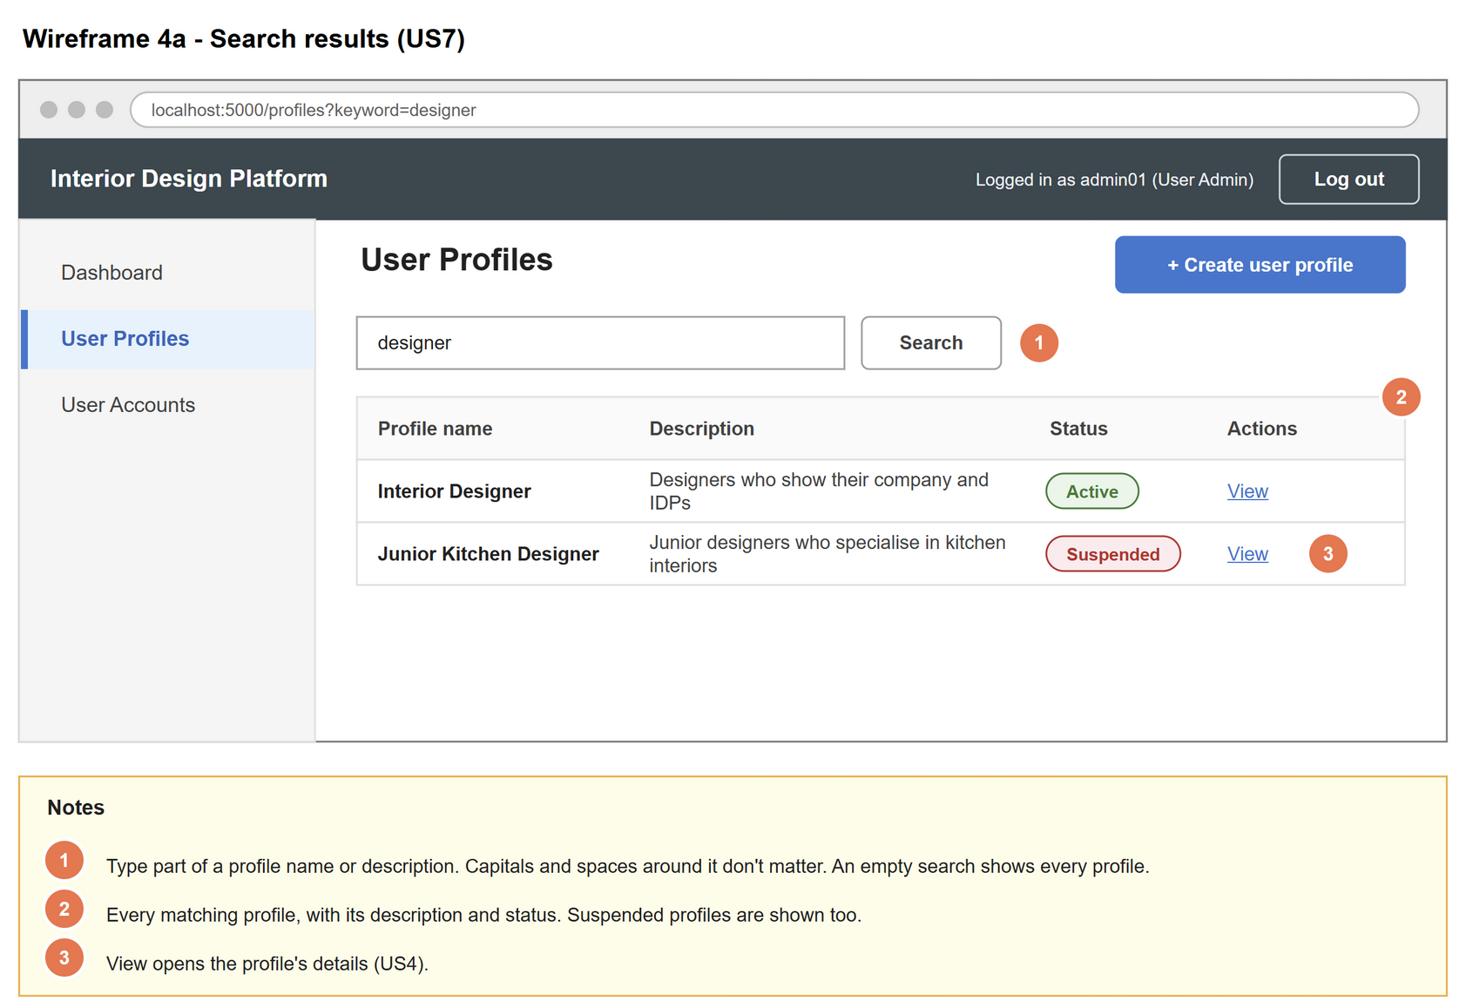
Figure 2: Wireframe 4a - Search results (US7)

4b - No results
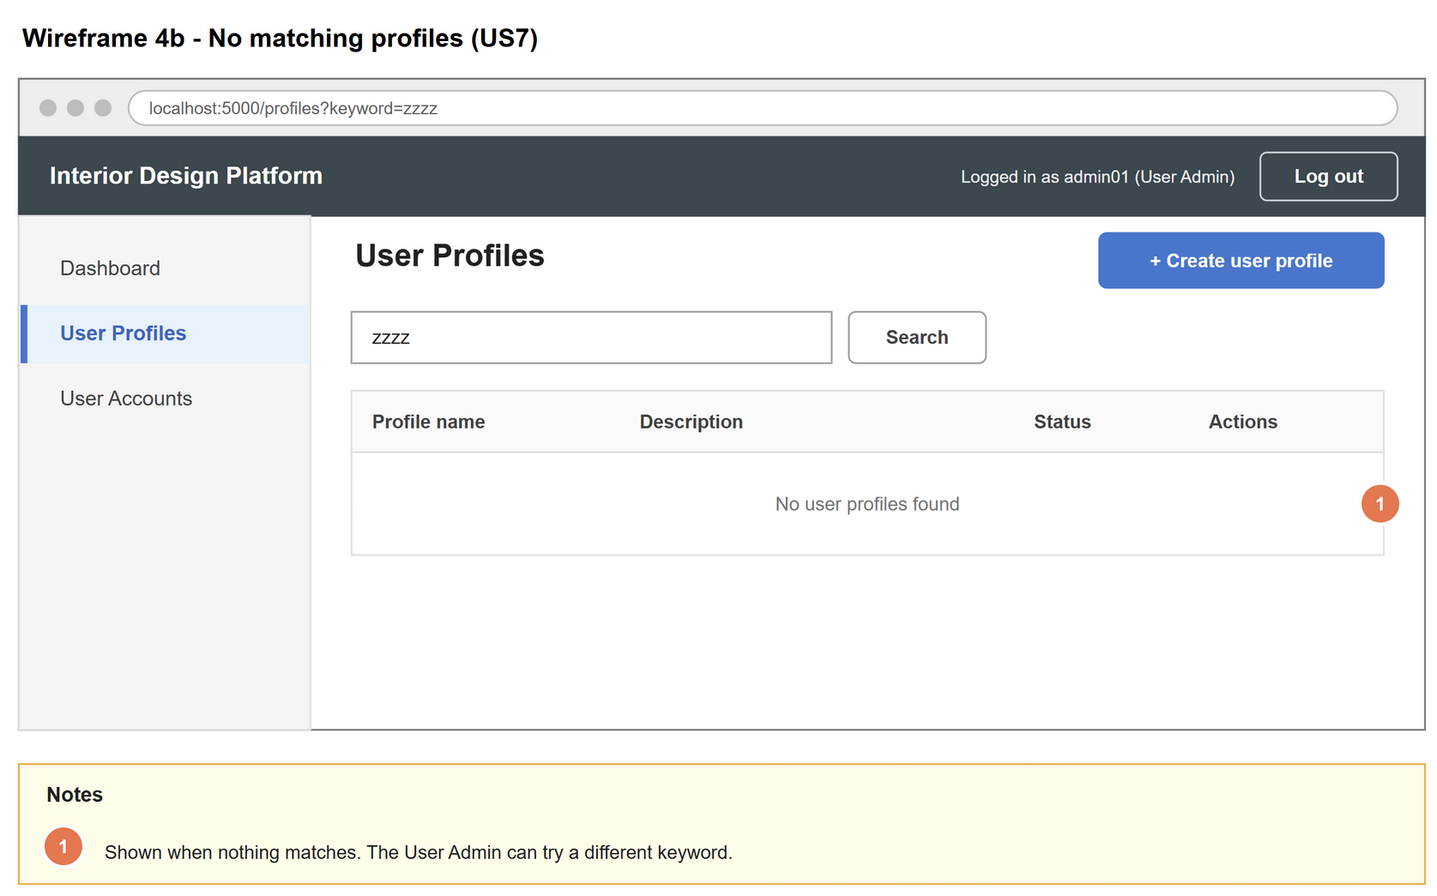
Figure 3: Wireframe 4b - No results (US7)

5. B-C-E class diagram
The solid line means the boundary calls the controller. The dashed line means the controller uses the entity class. Only the operations needed for this use case are shown.
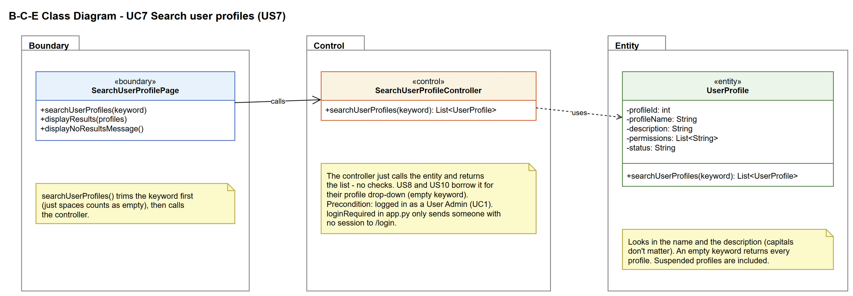
Figure 4: B-C-E class diagram for US7 Search user profiles
Layer | Class | What it does
Boundary | SearchUserProfilePage | The search box and results list on the User Profiles page. Gets the keyword from the User Admin, trims it, then shows either the results or the "No user profiles found" message. The User Admin only ever deals with this class.
Control | SearchUserProfileController | Controller for UC7. Just passes the keyword to UserProfile.searchUserProfiles() and returns the list of matches - no checks. US8 and US10 borrow it for their profile drop-down.
Entity | UserProfile | searchUserProfiles() finds the saved profiles with the keyword in their name or description (capitals ignored) and returns them as a list.

6. Sequence diagram
The sequence diagram follows UC7. The page trims the keyword first (note), then the keyword goes from the page to the controller to UserProfile, and the list of matching profiles comes back (steps 1 to 3). The alt box shows the two ways it can end: matching profiles are found and shown (basic flow), or nothing matches and a message is shown instead (alternative flow 3a). Every message in the diagram is an operation from the class diagram.
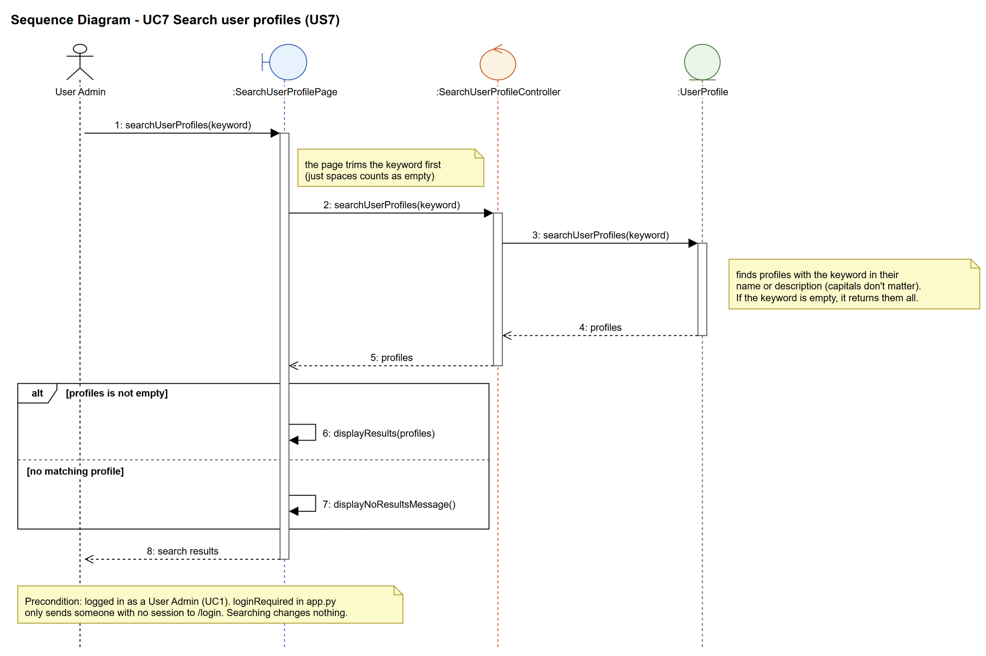
Figure 5: Sequence diagram for UC7 Search user profiles

7. Test cases
Test data used below (same as database/seedData.py): user profiles User Admin (id 1), Interior Designer (id 2), Customer (id 3) and Platform Manager (id 4), all Active. User accounts admin01 / Admin@123 (id 1, User Admin, Active), admin02 / Admin@123 (id 2, User Admin, Suspended), cust001 / Cust@123 (id 3, Customer, Active) and designer1 / Pass@123 (id 4, Interior Designer, Active).

7a. System test cases (black box)
Equivalence partitioning and boundary value analysis were used to pick the test data. Fill in "Actual result" and "Pass/Fail" after running each test.
Test ID | Scenario | Prerequisites | Test steps | Test data | Expected result | Actual result | Pass / Fail
TC7.1 | Search by profile name | Logged in as admin01. | 1. Type the keyword  2. Click "Search" | Customer | Customer is in the results, with its description and status.
TC7.2 | Search by description | Logged in as admin01. | 1. Type the keyword  2. Click "Search" | renovating | Customer is in the results (the word is only in its description).
TC7.3 | Capitals don't matter | Logged in as admin01. | 1. Type the keyword  2. Click "Search" | dESIGNER | Interior Designer is in the results.
TC7.4 | Part of a word | Logged in as admin01. | 1. Type the keyword  2. Click "Search" | Manage | User Admin and Platform Manager are in the results.
TC7.5 | Suspended profiles are shown | Logged in as admin01. Customer has been suspended (UC6). | 1. Type the keyword  2. Click "Search" | Customer | Customer is in the results with status Suspended.
TC7.6 | Empty keyword | Logged in as admin01. | 1. Leave the search box empty  2. Click "Search" | (empty) | All user profiles are shown.
TC7.7 | No match | Logged in as admin01. | 1. Type the keyword  2. Click "Search" | zzzzz | "No user profiles found".
TC7.8 | Spaces around the keyword | Logged in as admin01. | 1. Type the keyword  2. Click "Search" | " Customer " | Same result as TC7.1.

7b. Unit test cases (for TDD)
These are written before the code (test-driven development) and run with pytest (python -m pytest). They cover normal inputs, abnormal inputs and boundary values.
Test ID | Class and method | Input / setup | Expected output | Type | Pass / Fail
UT7.1 | UserProfile.searchUserProfiles() | "Customer" | Returns 1 profile: Customer | Normal | Pass
UT7.2 | UserProfile.searchUserProfiles() | "renovating" | Returns Customer (the word is only in its description) | Normal | Pass
UT7.3 | UserProfile.searchUserProfiles() | "dESIGNER" | Returns Interior Designer | Normal | Pass
UT7.4 | UserProfile.searchUserProfiles() | "Manage" | Returns User Admin and Platform Manager | Normal | Pass
UT7.5 | UserProfile.searchUserProfiles() | "" | Returns all 4 profiles | Boundary | Pass
UT7.6 | UserProfile.searchUserProfiles() | "zzzzz" | Returns an empty list (not None) | Abnormal | Pass
UT7.7 | UserProfile.searchUserProfiles() | "Customer" (Customer suspended first) | Returns Customer with status "Suspended" | Normal | Pass
UT7.8 | UserProfile.searchUserProfiles() | "Customer" | Nothing in user_profile changes | Normal | Pass
UT7.9 | SearchUserProfileController.searchUserProfiles() | "Customer" | Returns Customer | Normal | Pass
UT7.10 | SearchUserProfilePage.searchUserProfiles() (GET /profiles) | " " (spaces only) | Every profile is shown (the page trims it to empty) | Boundary | Pass
UT7.11 | SearchUserProfilePage.searchUserProfiles() (GET /profiles) | " Customer " | Customer is shown and Platform Manager isn't (the page trims the spaces) | Boundary | Pass
UT7.12 | SearchUserProfilePage.searchUserProfiles() (GET /profiles) | "designer" | Interior Designer is shown, Platform Manager isn't | Normal | Pass
UT7.13 | SearchUserProfilePage.searchUserProfiles() (GET /profiles) | "zzzzz" | "No user profiles found" is shown | Abnormal | Pass
UT7.14 | SearchUserProfilePage.searchUserProfiles() (GET /profiles) | no keyword | All 4 profiles are shown | Boundary | Pass
UT7.15 | SearchUserProfilePage.searchUserProfiles() (GET /profiles) | "Customer", not logged in | Redirected to /login (loginRequired) | Abnormal | Pass

